Thailand’s New Picture Cigarette Pack Warnings Officially Law

The new graphic health warning regulation of Thailand has been printed in the Royal Gazette on September 30, 2009. It will become effective in six months, allowing another three months for the phase out of products with the old warnings. Lobbying by the industry prevented a shorter phase out. In addition, one cigarette company submitted a letter questioning the health benefit of increasing the size of the graphic warnings from 50 to 55%. Obviously, if there really were no benefit, then there would be no reason to oppose the change.

The new graphic warning will contain ten pictures, seven the same as previously used. We have had difficulty finding suitable pictures, indicating a need for an international graphic picture bank. New features in the new regulation include:
- There are 3 new pictures
- The size of the pictures on both principle pack surfaces is 55% of the surface
- The warning will include the 1600 national quit line number
- Each carton is required to have all 10 pictures printed on it
- Inside each carton must be packs with at least two different graphic warnings

See the new pictures below.

Professor Prakit Vathesatogkit
Advisor to the Tobacco Control Office, Thai Ministry of Public Health
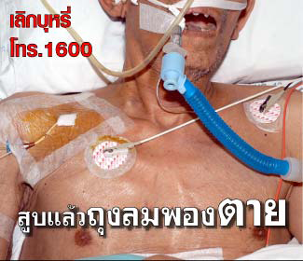

Form 1 Smoking Causes Emphysema

(All warnings include: “Quit Smoking, Call 1600”)

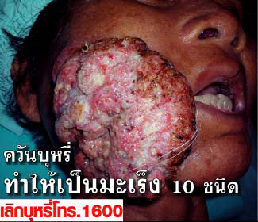

Form 2 Cigarette Smoke Causes 10 Different Kinds of
Cancer (NEW)

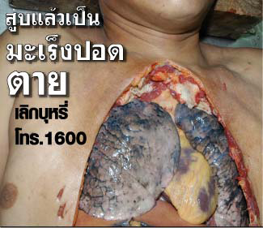

Form 3 Smoking Causes Lung Cancer



Form 4 Cigarette Smoke Kills Those Nearby

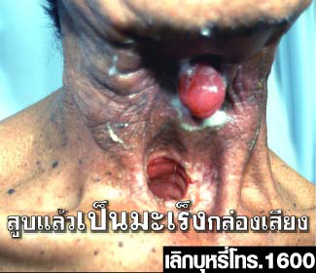
Form 5 Smoking Causes Throat Cancer

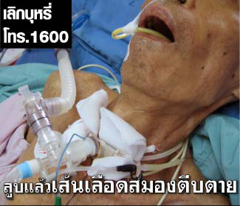

Form 6 Smokers Die from Stroke (NEW)

Form 7 Smoking Causes Mouth Cancer


Form 8 Smoking Causes Death from Heart Attack

Note: Picture Shows Part of the Thai Funeral Rite

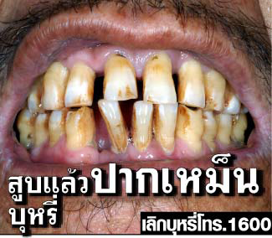

Form 9 Smoking Causes Foul Breath

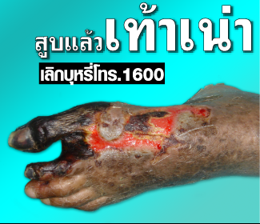

Form 10 Smoking Causes Gangrene (NEW)

Professor Dr. Prakit Vathesatogkit MD.
Executive Secretary ASH Thailand
Action On Smoking and Health Foundation Thailand
www.ashthailand.or.th
7 October 2009

