Japan Passes Thailand in Tobacco Reduction

Prof.Emeritus Prakit Wateesatogkit
December 2010

The rapid reduction of tobacco consumption in Japan was a popular topic of discussion and interest at the meeting 171, which is the 4th session of the Conference of the Parties to the WHO Framework Convention on Tobacco Control (COP4), held on 15-20 November 2010, in Uruguay.
The smoking consumption rate of males aged 20 and above in Japan is 37%, while in Thailand, the smoking consumption rate of males aged 15 and above is 39%, in which calculated as a rate of males aged 20 and above, it would be 40%. This means that males in Japan now have a lower smoking consumption rate than that in Thailand already. More importantly, the rate of smoking in Japan is following a trend of rapid reduction (as shown in the figure), particularly portrayed during after the year 2005, when Japan signed the Framework Convention on Tobacco Control.
Mrs. Yumiko Kobayashi, Tobacco Control Policy Project Leader, of the National Cancer Center Research Institute in Japan, summarized that the signing of the FCTC, of the WHO, was an important cause that resulted to the following progresses in tobacco control:
- It caused the political affairs to give attention and recognize importance of tobacco control policies.
- It instigated the government to have a vision and develop clear obligations in the protection of public health.
- Decrease in conflicts related to tobacco control policies within the government.
- It created a center of focus in tobacco control for the Ministry of Public Health, and two other departments of other health institutes.
- Acceptance, recognition and support to the civil society organizations, and academic institutes, in both of horizontal and vertical aspects of working.
- A variety of initiations from communities and allies of the tobacco control policy.
- Japan joined and supported the society of tobacco control in the world.
The turning point in Japan

This occurred during the years 2004-2005, after the Japanese government signed the FCTC. The government changed its policy from being inactive towards tobacco control, due to the fact the government was the owner of tobacco industry business, or Japan Tobacco, in which dominates in the local market, and moreover, bought the business from R.J. Reynolds in terms of international marketing, until it became the 3rd largest international company in the world, following from Philip Morris and BAT.
What it the government progressed towards was a policy of health protection from tobacco industry, which includes even their own company, Japan Tobacco.
This policy implied the importance of public’s health over the profit being made from tobacco industry, where the government has been the owner of.
Comparing to the Thai government, similarly, it can be referred as how the government emphasizes on the tobacco control policy of the Ministry of Public Health (MOPH), more than in support of the Thai tobacco industry, owned by the government.
The strategies of tobacco control conducted in Japan are strategies that were recommended by the FCTC, of the WHO, which are:
- Campaign the population to be aware of the harms in smoking.
- Increase in the tax applied on tobacco products 4 times within 7 years, which made the retail price of cigarettes rise from 250 Yen in 2003 to become 410 Yen in 2010, where the health organizations actually are aiming to increase tax until the price reaches 1,000 Yen.
- The prohibition of smoking public areas.
- Support and provision of assistance for smokers to quit in a large scale amount, through providing reimbursement in buying drugs that help to quit smoke, and having up to 10,000 quit smoking clinics. These are only the main performances that Japan accomplished.

Looking to the future

Japan hasn’t just stopped there at that point.
They have targeted to decrease the amount of deaths from cancer caused from smoking by 73,000 deaths per year.
This would be done by passing the law on cancer prevention and control, and passing the law on health promotion, in which the policy in cancer control would emphasize important strategies related to tobacco control, since tobacco is a main cause that can be able to prevent up to 10 types of cancer.

What are the aspects of success?

If we were to answer what aspects contributed to Japan’s great progress in tobacco control, then we cannot overlook the fact that the country generally has a developed society, in a variety of ways, especially how they are full of quality people. Whenever Japanese people put effort and willingness to do something, they would often accomplish it well, and moreover, at a quicker rate than other countries. From the experience of having attended many FCTC meetings in the recent years, the writer was able to observe clearly how the representative of Japan has changed from having an attitude that was always disagreeing to tobacco control recommendations from other countries, to having a more compliant attitude now.
Most interestingly, in this past meeting at Uruguay, the representative of Japan was actually one of the main convincers for the Chinese representative to agree with the practice guideline, drafts 9 and 10 of the FCTC, which is about the elimination and prohibition of flavored tobacco production. The agreement ended without having to make any changes in the contents that the committee developed in the drafts in that meeting. All that can be said is that Japan was fully appraised for their success, in which many were surprised of. In looking back to our own country, where people are still working in the same Thai ways, and are still proud that Thailand is the leader in tobacco control, while politicians are disagreeing with each other due to personal objectives, it is worrying to see that the smoking rates of males in Thailand have stopped decreasing for many years. Even in Vietnam, has there been a decrease in the male smoking rate which has reached the same rate as Thailand already.

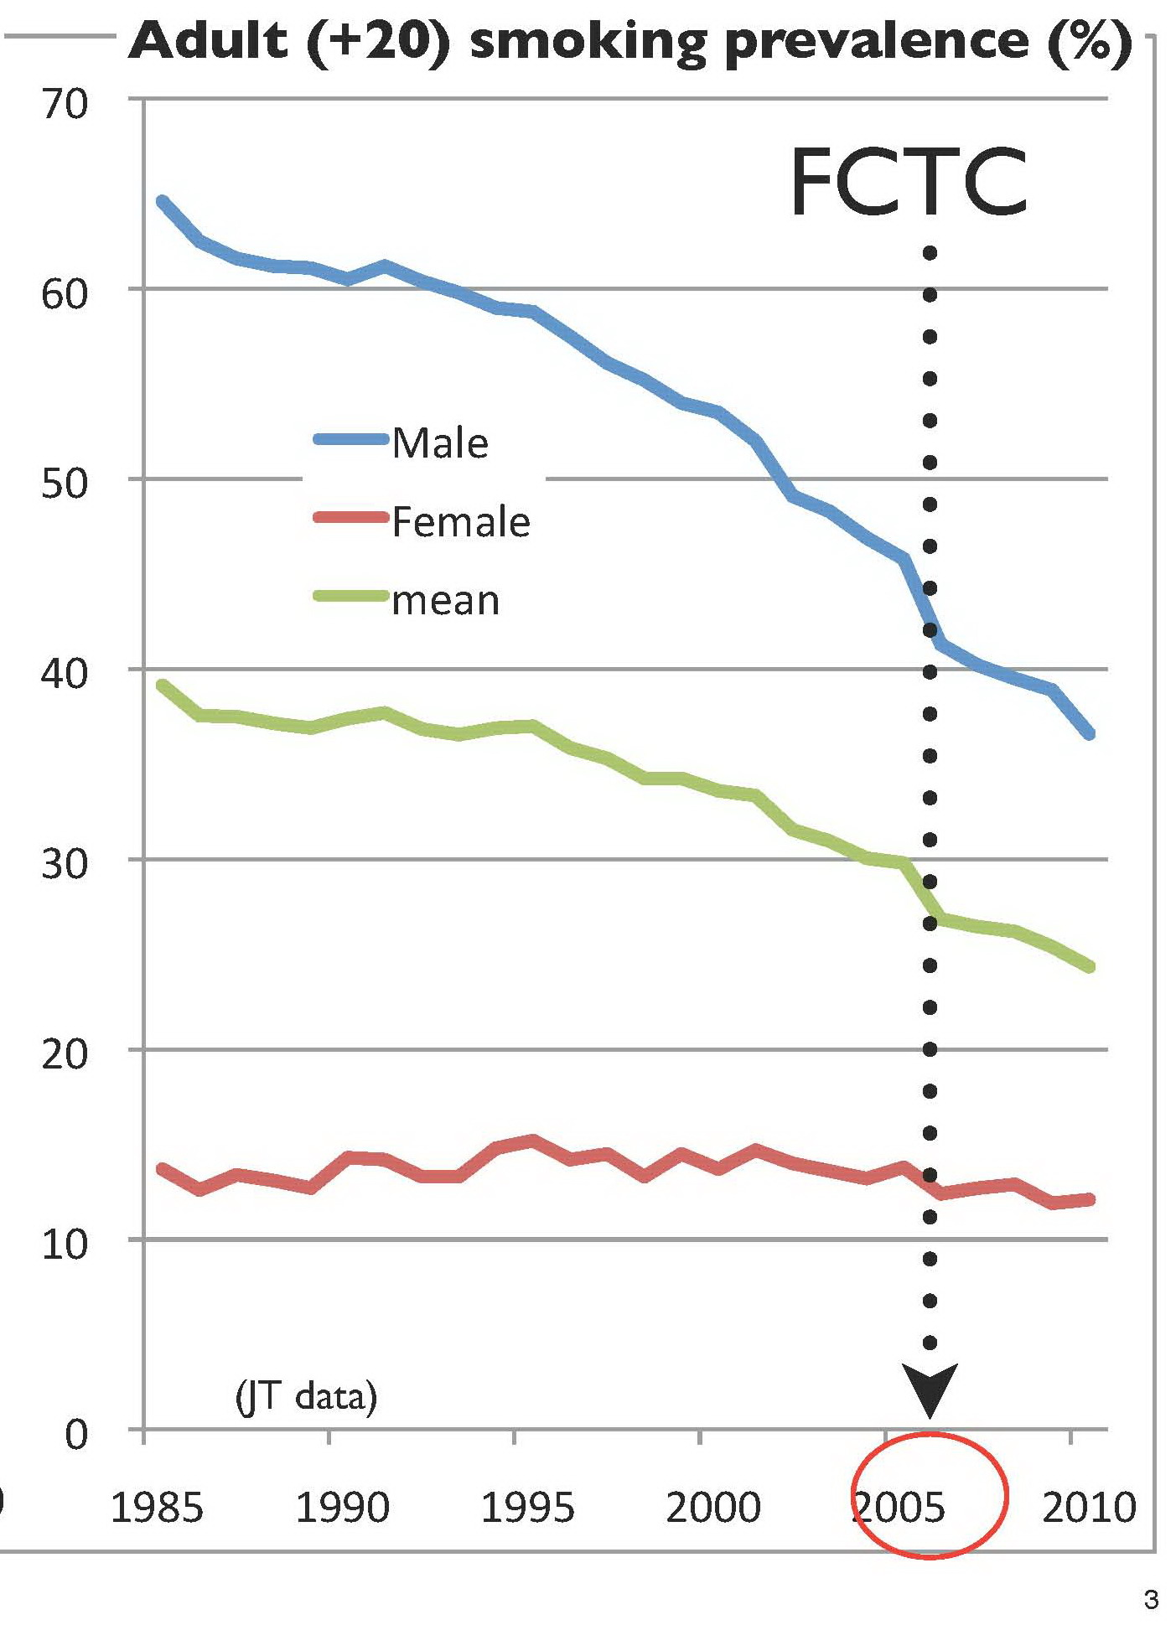

The figure above portrays the smoking rate of males in Japan, which has decreased from 65% in 1985 to 37% in 2010, while the smoking rate of females in Japan is at 12-14%, during the same period which they signed the FCTC in 2005.

